Ideation Phase

Empathy Map Canvas

Date | 06 November 2025
Team ID | F529277D47452DB9E7447BD087E08E5E
Project Name | Medical inventory management
Maximum marks | 4 marks

🎯 User Persona
Primary User: Hospital inventory manager / pharmacist / nurse
Goal: Efficiently track, manage, and restock medical supplies to avoid shortages or waste.

👂 1. Says
What the user explicitly says about their experience or needs:
- “We’re always running out of critical medicines at the wrong time.”

“It’s hard to keep track of expiry dates manually.”
- “I spend too much time updating stock in spreadsheets.”
- “We need a system that gives alerts before stock runs low.”
- “Reports should be easy to generate for audits.”

👀 2. Thinks
What the user might be thinking but not saying out loud:
- “If we miss even one supply, it could affect patient care.”
- “Manual tracking increases the chance of errors.”
- “I wish this process was automated and transparent.”
- “The current system wastes too much time and effort.”
- “What if expired medicines are used accidentally?”

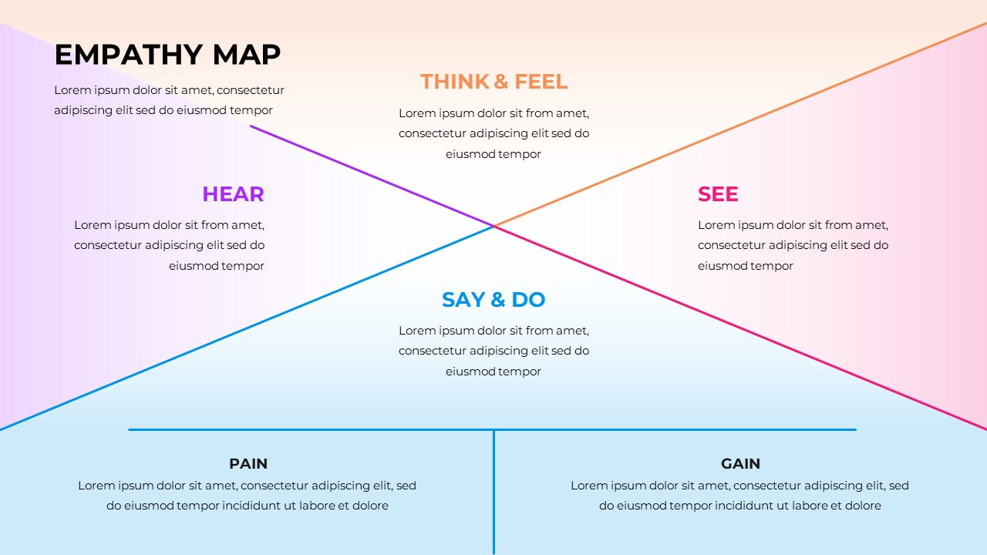

💬 3. Does
Observable user actions:
- Manually updates inventory in spreadsheets or notebooks.
- Physically checks stockrooms to verify quantities.
- Calls suppliers for restocking.
- Creates manual purchase orders.
- Cross-checks expiry dates item by item.

❤️ 4. Feels
Emotions and frustrations:
- 😩 Frustrated — with manual work and data errors.
- 😰 Anxious — about missing or expired stock.
- 😠 Stressed — during audits or inspections.
- 😊 Relieved — when alerts and reports are automated.
- 💪 Empowered — when the system is accurate and easy to use.

🌟 5. Pain Points
The main challenges faced:
- Lack of real-time visibility of stock.
- Manual entry errors and duplication.
- Difficulty tracking expiry dates.
- Delayed replenishment and procurement.
- Inefficient reporting and compliance processes.

💡 6. Gains
Desired outcomes or benefits:
- Automated low-stock and expiry alerts.
- Real-time dashboards for stock levels.
- Easy report generation for audits.
- Seamless supplier integration and purchase tracking.
- Better patient safety and cost control.

👤 Summary Insight
Users want a reliable, automated, and user-friendly system that ensures availability, accuracy, and safety in managing medical supplies — reducing stress and improving operational efficiency.

